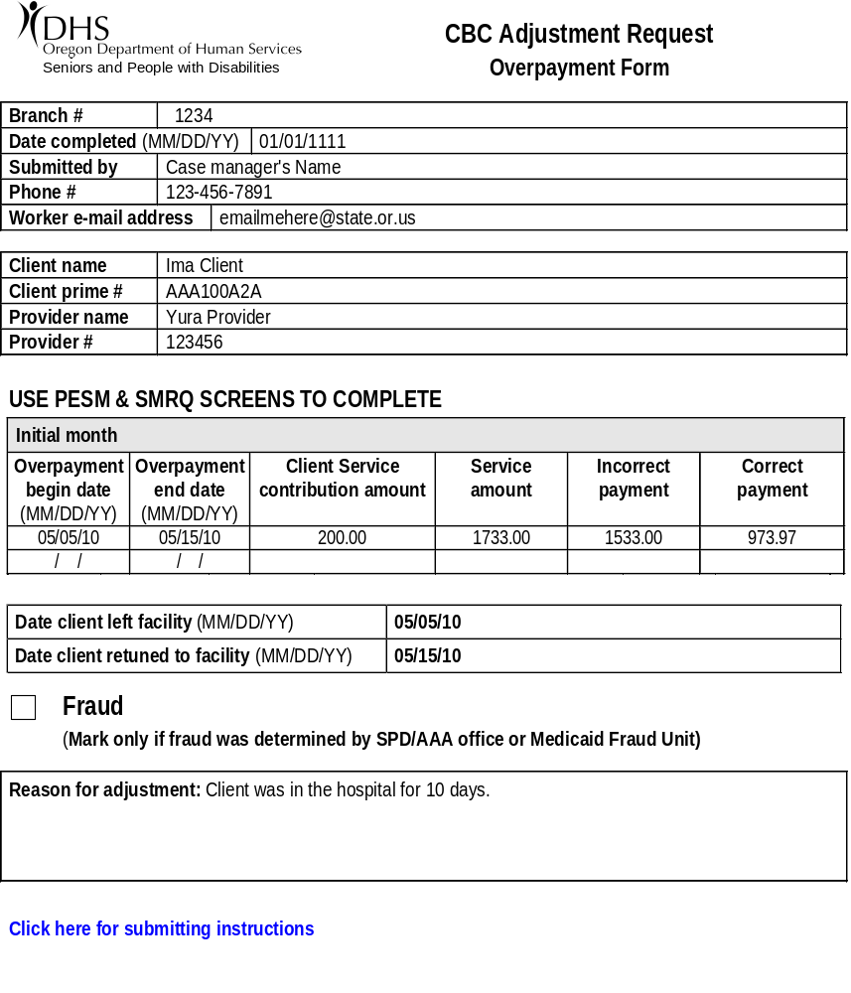
Be sure to fill in all CM contact info, client info and provider info!
Dates overpayment began and ended
Portion of the service amount the client is responsible to pay. Found in 512 on DISB screen across from SVC CNTB. This amount DOES NOT include room and board.

Total service amount for the month. Found on the 512 on the DISB screen across from SVC AMT
Brief description of why the adjustment is being made
Incorrect amount paid. Found on SCLM,R,Prime#
Amount that SHOULD HAVE been paid. (see equation example)

